# SoapUI Document

SoapUI official site document – 2019.5.2 14:26 PM

# JDBC Connections

On a Project level (available for SoapUI Pro version only) there is an option for configuring JDBC Database Connections which you can use afterwards in JDBC DataSource, JDBC DataSink and JDBCRequest TestSteps. In Order to be able to configure a DatabaseConnection there have to be Driver and Connection String template add in Global Preferences – Jdbc Drives Properties panel (accessed from File menu 🡪 Preference 🡪 JDBC Drives Properties tab). A number of templates are supplied by default but you can also add new ones if you need additional.

Which properties you have supply for the connection is defined by the connection string template, and if you have a JDBC connection configured for the specific database that includes no password for instance then you have to add another template that won’t include (all properties shown in the wizard panel have to supplied).

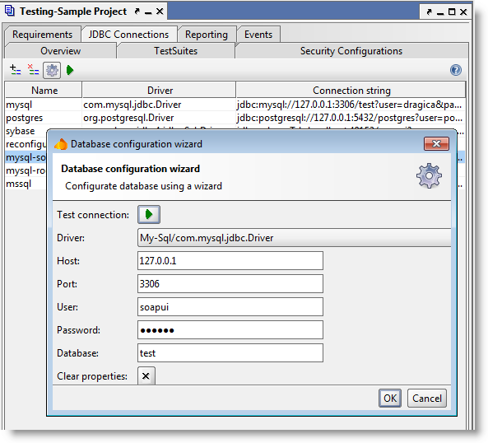

You also have an option of testing supplied properties before you confirm the configuration.

Connections configured on a project level can later be used in JDBC DataSource, JDBC DataSink and JDBCRequest TestSteps.